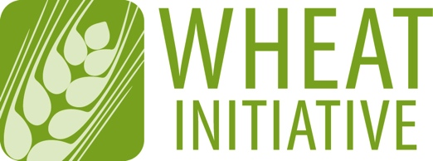
Coordinating global research for wheat

ANNEX 2
EXPERT WORKING GROUP MEMBERSHIP APPLICATION FORM
Please return your completed form to wheat.initiative@julius-kuehn.de (maximum 4 pages)

NAME OF EXPERT WORKING GROUP
Control of Wheat Pathogens

EXPECTATIONS FOR EWG MEMBERS
- Participate in EWG meetings and ongoing discussions
- Contribute to the activities of the EWG
- Expertise in the following topics
- Host-pathogen interactions involving wheat and wheat pathogens with different lifestyles
- Control of mycotoxin production
- Diagnosis and monitoring of wheat diseases
- Development and maintenance of pathogen collections
- The genetics and breeding of host resistance to wheat diseases
- Fungicide development and/or application, and integrated strategies to manage crop losses to diseases
- Other aspects of disease control

1 - CANDIDATE DETAILS
First Name
Last Name
Position
Country
Institution/Company
Employment sector | Public ☐ Private ☐ Self Employed ☐
Area | Government ☐ Industry ☐ Non-Profit ☐ Research Center ☐ University ☐
Email

2 - PROFESSIONAL ACTIVITIES
Research Activities
Other Activities

3 - PUBLICATIONS RELEVANT TO THE EWG TOPIC

4 - OTHER TYPES OF PRODUCTIONS

5 - ADDITIONAL INFORMATION (in particular, reasons why you would like to be a member of the EWG and what specific expertise or relevant experience you could contribute to its development)

We would like to inform you that your data will been included in our address database for the purpose of association communication in accordance with Art. 6 para. 1 General Data Protection Regulation (German law).The following will have access to this address database: The Wheat Initiative Secretariat for the purpose of building and continuing the network of the Wheat Initiative. This will include distribution lists of Expert Working groups, forwarding of information of single members to each other, inform and connect.

For further information please look on our website: https://www.wheatinitiative.org/data-protection or contact the Wheat Initiative Secretariat under wheat.initiative(a)julius-kuehn.de

