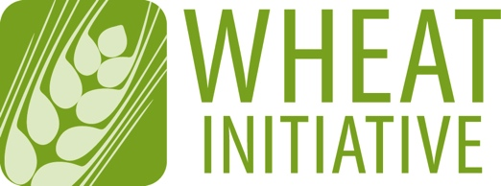
Coordinating global research for wheat

ANNEX 2 (Oct 2020 update)
EXPERT WORKING GROUP MEMBERSHIP APPLICATION FORM
Please return your completed form to wheat.initiative@julius-kuehn.de (maximum 4 pages)

NAME OF EXPERT WORKING GROUP
Global Wheat Germplasm Conservation and Use Community EWG

EXPECTATIONS FOR EWG MEMBERS
- Participate in EWG meetings and ongoing discussions
- Contribute to the activities of the EWG
- Expertise in the following topics (Genebank Management, Cereal crop conservation, Diversity assessment, seed physiology, breeding, pre-breeding, cytogenetic, cereal taxonomist, pathology, physiology, bioinformatics, information systems, end use quality, and in situ conservation)

1 - CANDIDATE DETAILS
First Name
Last Name
Wheat Initiative
Website Username*
Position
Country
Institution/Company
Email

2 - PROFESSIONAL ACTIVITIES
Research Activities
Other Activities

3 - PUBLICATIONS RELEVANT TO THE EWG TOPIC

4 - OTHER TYPES OF PRODUCTIONS

5 - ADDITIONAL INFORMATION (in particular, reasons why you would like to be a member of the EWG and what specific expertise or relevant experience you could contribute to its development)

